**C:\Users\st11223\Desktop\MIT LOGO ETC\New MIT Logo.png **

**NEW ZEALAND MARITIME SCHOOL**

**NZ Diploma in Marine Electro-technology (NZ2894)**

**(STCW 1978 A-III/6, as amended in 2010)**

**Electro-Technical Officer, Year 2 Cadets, 2020.**

**Course Code**

942.580 - AS01.

**Course Title**

Maintenance and Repair of Automation and Control Systems of Main Propulsion and Auxiliary Systems.

Learning Outcomes Assessment.

**Format**

Written assignment of 1000 words including diagrams and marked Competent (C) or Not-Yet Competent (NYC). Weighting = 50%.

**Due Date**

To be submitted by email to [nick.cossar@manukau.ac.nz](mailto:nick.cossar@manukau.ac.nz) for the due date of 03/05/2019.

**Tutor**

Nick Cossar

[nick.cossar@manukau.ac.nz](mailto:nick.cossar@manukau.ac.nz)

**Student Name:**

**Student ID:**

**Date:**

Describe the Electrical Instruments used by an ETO for fault finding on a modern ship’s propulsion main engine as per Learning Outcome 1: maintenance procedures and repair of main propulsion with specific reference to:

* power supply
* cabling and grounding
* switchboards, terminal strips, connectors and cards replacement
* indication lamps
* ventilation, heat, ambient condition
* RPM and pitch indication
* overload indication
* UMS engineer alarm system clutch remote control
* RPM remote control
* pitch remote control
* back up control
* alarms and control set points
* outputs and inputs PLC
* emergency stop and start
* shutdown and slowdown
* broken wire alarm
* systems of reversing propeller shaft
* tacho-generator

Describe the types of instruments used (such as multi-meters, calibrators and any other instruments) to assist with locating faults along with the types of signals and information expected.

## Power Supply

In the event of a suspected failure of a power supply, typically a live-line tester for instant awareness of the presence of power will be used. In low voltage applications, a multimeter should be used on the Volts AC/DC (depending on the supply type) and connected from each line to ground (if there are multiple phases in this supply configuration) on both the input and output, especially if it is a transforming or rectifying/inverting supply. The readings taken should be no more or less than 5-10% of the expected supply of power e.g. 240V where the source is 250V. Frequency may also be checked with this multimeter.

In high voltage, absolutely no work should be performed on or near any live lines. If a power supply failure is detected, be sure to de-energize and earth all equipment safely before proceeding with diagnostics.

## Cabling and Grounding

Cabling’s resistance may be checked from end-to-end, although typically this may be calculated for new cable installations, a precision multimeter may be used for accurate information. Typically in checking older cables of a long run, a regular multimeter may be used to ensure simply there are no breaks or wear from end to end via the ohms setting and a reading of <1 ohm.

In addition to resistance end-to-end, insulation resistance can be checked with a megohm meter. In a setting of Volts DC of one tier higher than whatever the expected voltage of the consumer is, e.g. 500VDC setting for a 390V motor.

## switchboards, terminal strips, connectors and cards replacement

Each component of a low voltage switchboard, including all terminal strips, connectors and cards, may be safely tested visually, or by using an IR camera during operation to check for hot spots. Depending on the issue, a multimeter or front panel meter [if installed] may also be used to check the voltage levels are correct. A clamp meter either pre-installed or attached to a multimeter, may be used to check current levels. Continuity testing may be required throughout the installation to “narrow down” any potential fault within the board. A multimeter may be used for this, on Volts (preferably with buzzer enabled) and simply follow through the circuit with the relevant circuit diagram. This may also be done on the Ohms setting WHILE the circuit is de-energized. The same may be done with cards, although an ESD bracelet is recommended, and the Ohms setting of a multimeter is used to procedurally check each relevant component.

## indication lamps

Indication lamps, if not wired directly into a “test circuit”, may be removed and powered on separately for testing. Generally, an electrician’s workshop will have a panel for testing lamps (i.e. sockets).

For LEDs specifically, checking that the diode itself is working is a quick way to gauge the health. This can be done with the “diode” setting on some, but not all multimeters. If the LED is working correctly then the display should read a clean 1600 mV.

## ventilation, heat, ambient condition

For HVAC, a handheld temperature sensor should be used in addition with the system’s own internal temperature sensing. An ambient pressure sensor may also be used in the case of overpressure/underpressure situations caused by faulty HVAC.

## RPM and pitch indication

For RPM of a machine a tachometer may be used, preferably the non-contact laser variety.

For RPM and pitch indication a multimeter or 4-20mA clamp meter may be used depending on the type of signal expected. For voltage signals, the multimeter is used, for current signals, the clamp meter should be used. In the case of unusual or difficult to read signals, i.e. PWM, CAN/MODBUS an oscilloscope may be used.

## overload indication

A transducer mounted on a shaft of the rotating equipment to convert known frequency and torque measured by the transducer into a numerical scalar for mechanical power. This value can be cross-referenced with manufacturer specifications to confirm an overload state. Raising the motor to an overload state just above the indication threshold is the best way to test any overload indication.

Data on the ECU may be used in place of a torque transducer. The data on the ECU should be checked and calibrated beforehand to ensure accurate information.

This test is performed when a 5-yearly registry check is performed.

## UMS engineer alarm system

Testing the UMS may be as simple as configuring the system to divert alarms to another location and raising an alarm after informing bridge & technical crew [and possibly passengers, depending on the alarm] that such a test is taking place. Although not the best practice, most alarms may be safely raised and dismissed, and each can be checked safely.

## RPM remote control / pitch remote control

If the situation is that the RPM or Pitch remote control is not working, check first that they are in fact functional on the local panels. If that is the case, then using a multimeter or 4-20mA clamp meter to check the signals at both sides of the cable which is intended for carrying the relevant signal. If signal appears at both ends [cleanly] then efforts should be focused on the remote-control panel with multimeter and potentially a Process meter to assist with calibration. If the terminating end of the cable does not receive a signal, check the cable integrity with a megohm meter and end-to-end resistance with a precision multimeter. [pictured below]

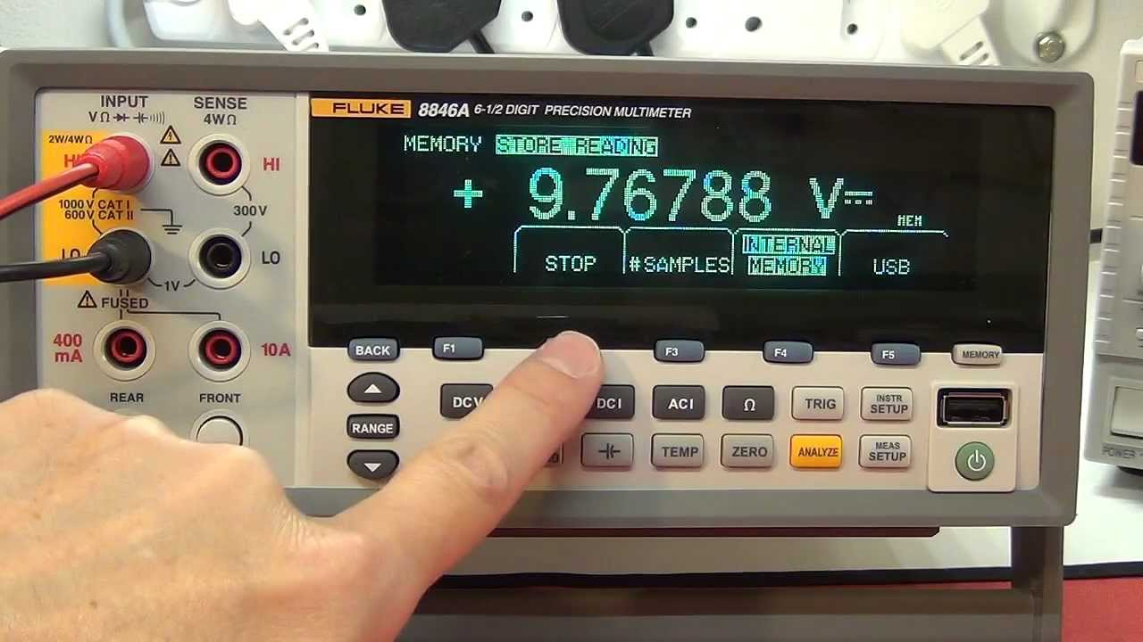

## back up control

## alarms and control set points

Alarms and control set points may be tested using a device which can inject a synthesized signal into the device. For instance, a Process meter may be used to generate a 4-20mA signal and ramp up carefully to the point where the alarm is designed to operate.

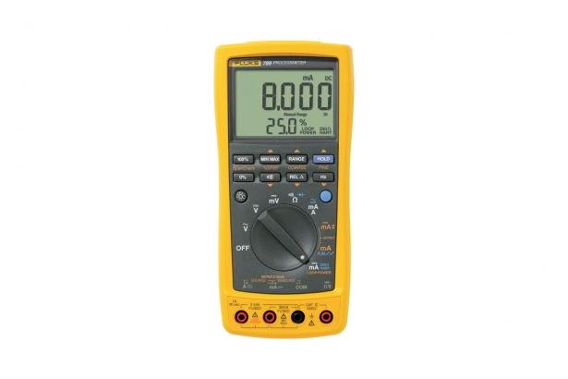

A process meter

## outputs and inputs PLC

All the outputs and inputs of a PLC will generally be a signal which may be read by a multimeter. The outputs tend to be on or off and therefore the Volts setting on a multimeter will be sufficient to check their ‘position’. Inputs may be more nuanced and any analogue signal will need a 4-20mA clamp meter to check the current levels.

## emergency stop and start

On a main propulsion motor, simply decommission the motor at layover by isolating the starting air valves. A permit will likely be required to be filed first for this work. Once isolated, and the engine is in the “local” control setting (certain engines may also be fitted with a “test” mode) will allow the e-stop and e-start to be run whilst any issues with those commands can be diagnosed using the ECU. The panel interface and onboard alarm system should also indicate failure/success. Testing with air (i.e. an actual e-start and actual e-stop) may be performed although the engine should be pre-heated first and this should be run in a controlled environment. This may be part of a routine maintenance cycle every 3, 6, 12 months or so as it may degrade the lifespan of the engine.

## shutdown and slowdown

Shutdown is easy to test, hard to diagnose. The manufacturer will have a list of actions performed during a standard shutdown which each can be individually checked to ensure safe operation of the shutdown procedure. Slowdown is easier to check as the slowdown command may be sent electronically via the onboard computer system, or local governor control.

Depending on the configuration of the ship, the engine order telegraph may also be used while the engine is off and reading the signal from the onboard computer system or an analogue value which may be read by any connected PLC/ a multimeter to ensure accurate speed information is being sent to the engine.

## tacho-generator

A tacho-generator produces an extremely accurate value of DC voltage which represents the rotation and precise speed of rotating machinery. Using a precision multimeter to read this value as well as a laser tachometer is potentially the best way to confirmed the 0-10VDC value is roughly accurate and the tacho-generator is functioning properly.

**Resources**

* + CANVAS.
  + Hall – Practical Marine Electrical Knowledge.
  + Hughes – Electrical and Electronic Technology.
  + Lloyds of London Rules and Regulations for the Classification of Ships July 2018.